Report:

Title: Uniaxial Tensile Test

1. **Objective**

The objectives of this experiment are to ascertain the following in specimens made of aluminium and mild steel that have undergone uniaxial loading. Also, compute:

1. The maximum tensile stress.
2. The modulus of elasticity
3. The percentage reduction in cross section and hence strain to failure assuming plastic incompressibility
4. Construction of the true-stress vs. true stain curve.
5. **Experimental Method(s):**
6. Average the diameter "d" of the specimen by measuring it at various points.
7. Ensure consistency by setting the gauge length L to 5d, resulting in a value of 20 mm.
8. Identify the centre of the specimen and locate two additional points on either side, 10 mm away from the centre.
9. Install the specimen on a Universal Testing Machine (UTM) and adjust the load range and crosshead velocity accordingly.
10. Continue applying load until the specimen fractures and gather data from both the UTM and extensometer, which records the strain over time.
11. Reassemble the broken pieces of the specimen and calculate the percentage elongation at failure by measuring the distance between the marked points, cross-sectional area, and other relevant factors.
12. **Results and Calculations:**

|  |  |
| --- | --- |
| **For Mild Steel:** | **For Aluminium:** |
| Initial diameter of specimen d1 = 6.94 mm | Initial diameter of specimen d1 = 6.85 mm |
| Initial diameter of specimen d1 = 6.94 mm | Initial gauge length of specimen L1 = 100 mm |
| Initial cross-section area of specimen A1 =151.234 mm2 | Initial cross-section area of specimen A1 = 147.337 mm2 |
| Diameter of specimen at breaking place d2 = 3.9mm | Diameter of specimen at breaking place d2 = 3.16 mm |
| % Reduction in area (𝐴𝑓−𝐴𝑖 /𝐴𝑖 ×100) = 53.175% | % Reduction in area (𝐴𝑓−𝐴𝑖 /𝐴𝑖 ×100) = 72.96% |
| Final gauge length Lf (MS) = 105.6 mm | Final gauge length Lf (Al) = 109.4 mm |

* 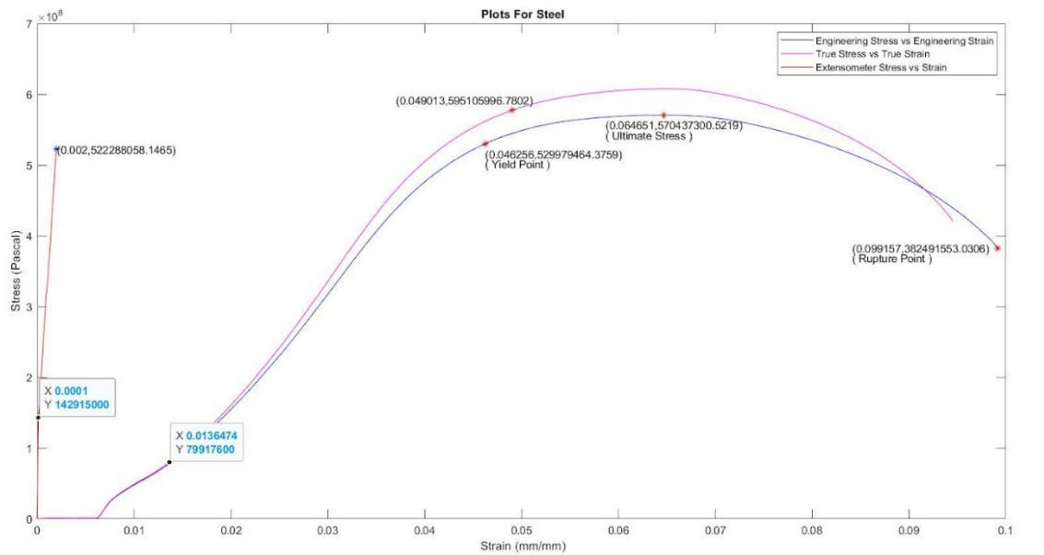**Mild Steel**

The Engineering Stress - Strain and True Stress - Strain curves for data from Extensometer coincide.

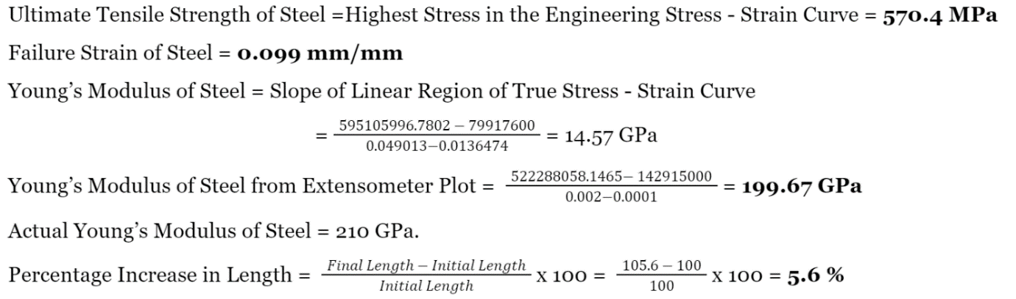Yield Strength of Steel = **530 MPa**

* **Aluminium**

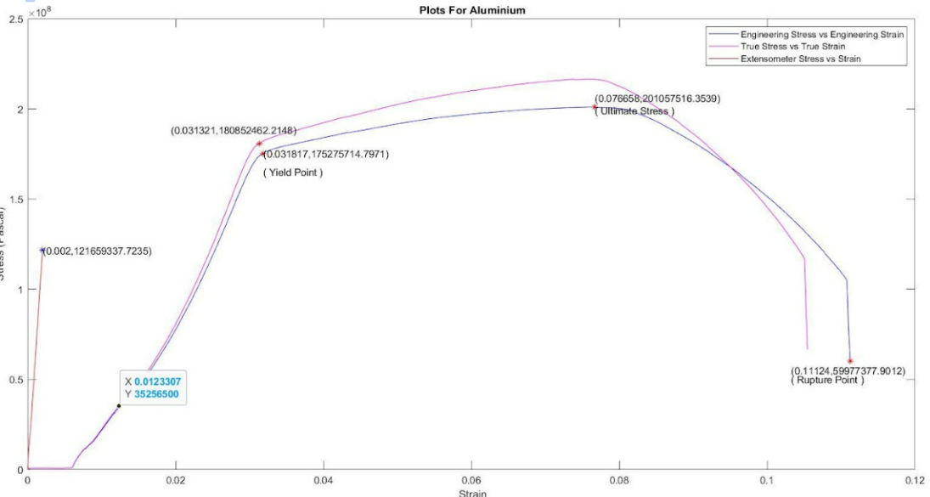

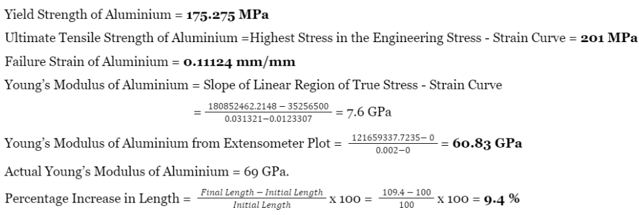 The Engineering Stress vs Strain and True Stress vs Strain curves for data from Extensometer coincide.



1. **Analysis/observations/discussion**
2. The findings of the tensile test on aluminium and mild steel were reliable and consistent. It was demonstrated that mild steel has significantly higher stiffness and tensile strength than aluminium.
3. A structural component's deflections are governed by a quantity called Young's modulus, and aluminium has a higher rate of ductility than mild steel.
4. Instrumental error and changes in the atomic structure attributes of the materials utilised were to blame for the results' small deviations from the specified values.
5. The specimen can crack at any point because it also depends on the rod's or specimen's flaws.
6. The experimental results for the two specimens' tested material properties were within a few percent of the values that had been established..
7. **Summary/conclusions.**
8. Steel has higher Yield Strength than Aluminium.
9. Young’s modulus of steel is greater than that of Aluminium.
10. The calculated values of Young’s Modulus from the extensometer data are fairly close to their book values.
11. Aluminium is more ductile than Steel as it has higher change in area as compared to Steel. Also as expected due to geometric compatibility, a larger percentage change in length corresponds to a larger percentage change in area.
12. **Sources of error**:
    * 1. The large differences in Young’s Modulus may arise due to high loading speed of Universal Testing machine, which can lead to errors in the recorded data.
      2. Error could also be there due to slight elongation of the jaws of UTM and friction between the jaws and the specimens.